Week 4 Assignment

Connect to the SQL server as you did for last week’s assignment and answer the following questions. When submitting your solution, copy and paste your SQL code in the textbook and upload a screenshot of your query result.

- It is September 12, 2023. Your clinic (Department_Key = 21, MEDICAL ASSOCIATES) is planning for the start of the next flu season on October 1, 2023.

  - How many total patients are there per provider (PCP, primary care provider) at your department?

SELECT
p.Provider_Key,
p.Provider_Name,
COUNT(pt.Patient_Key) AS Total_Patients
FROM dbo.providers p
LEFT JOIN dbo.patients pt
ON pt.PCP_Provider_Key = p.Provider_Key
WHERE p.Provider_Department_Key = 21
GROUP BY
p.Provider_Key,
p.Provider_Name
ORDER BY
p.Provider_Name;

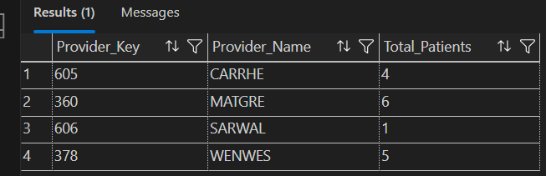
  - A different flu shot is needed depending on age:
Flucelvax Quadrivalent 0.5-17 years 0.5 mL
Flublok Quadrivalent 18-64 years 0.5 mL
Fluzone High-Dose Quadrivalent ≥65 years 0.7 mL

How many of each flu shot types will be needed for each PCP at your clinic?
WITH Patient_Ages AS (
SELECT
pt.Patient_Key,
pt.PCP_Provider_Key,
DATEDIFF(YEAR, pt.Patient_Birth_Date, '2023-09-12')
- CASE
WHEN DATEADD(YEAR, DATEDIFF(YEAR, pt.Patient_Birth_Date, '2023-09-12'), pt.Patient_Birth_Date) > '2023-09-12'
THEN 1 ELSE 0
END AS Age
FROM dbo.patients pt
),
Vaccine_Group AS (
SELECT
Patient_Key,
PCP_Provider_Key,
CASE
WHEN Age BETWEEN 0 AND 17 THEN 'Flucelvax Quadrivalent'
WHEN Age BETWEEN 18 AND 64 THEN 'Flublok Quadrivalent'
WHEN Age >= 65 THEN 'Fluzone High-Dose Quadrivalent'
END AS Flu_Shot_Type
FROM Patient_Ages
)
SELECT
p.Provider_Key,
p.Provider_Name,
vg.Flu_Shot_Type,
COUNT(*) AS Patients_Needing_Shot
FROM Vaccine_Group vg
JOIN dbo.providers p
ON p.Provider_Key = vg.PCP_Provider_Key
WHERE p.Provider_Department_Key = 21
GROUP BY
p.Provider_Key,
p.Provider_Name,
vg.Flu_Shot_Type
ORDER BY
p.Provider_Name,
vg.Flu_Shot_Type;
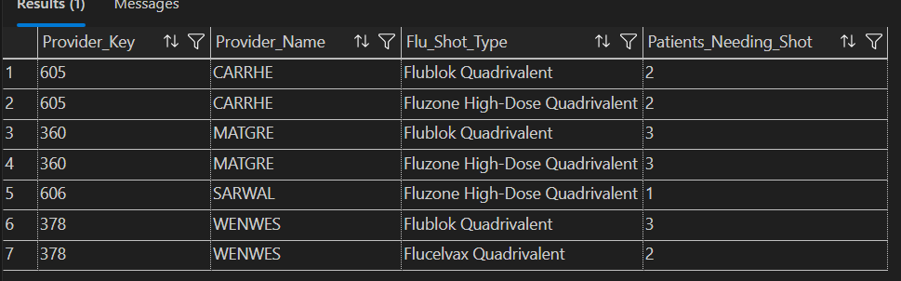

2. We consider a patient to be an active patient if they had two or more encounters in the dataset provided.

- How many active patients are in each age group?
Age Group 1: 0-17 years
Age Group 2: 18-64 years
Age Group 3: 65 years or older

WITH Active_Patients AS (
SELECT
e.Patient_Key
FROM dbo.encounters e
GROUP BY e.Patient_Key
HAVING COUNT(*) >= 2
),
Patient_Ages AS (
SELECT
pt.Patient_Key,
DATEDIFF(YEAR, pt.Patient_Birth_Date, '2023-09-12')
- CASE
WHEN DATEADD(YEAR, DATEDIFF(YEAR, pt.Patient_Birth_Date, '2023-09-12'), pt.Patient_Birth_Date) > '2023-09-12'
THEN 1 ELSE 0
END AS Age
FROM dbo.patients pt
JOIN Active_Patients ap
ON pt.Patient_Key = ap.Patient_Key
)
SELECT
CASE
WHEN Age BETWEEN 0 AND 17 THEN 'Age Group 1: 0-17'
WHEN Age BETWEEN 18 AND 64 THEN 'Age Group 2: 18-64'
WHEN Age >= 65 THEN 'Age Group 3: 65+'
END AS Age_Group,
COUNT(*) AS Active_Patient_Count
FROM Patient_Ages
GROUP BY
CASE
WHEN Age BETWEEN 0 AND 17 THEN 'Age Group 1: 0-17'
WHEN Age BETWEEN 18 AND 64 THEN 'Age Group 2: 18-64'
WHEN Age >= 65 THEN 'Age Group 3: 65+'
END
ORDER BY Age_Group;
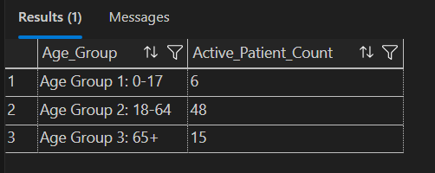

- Which PCPs in which departments have the largest number of active patients? To answer this question, provide a rank ordered list for each department with number of active patients (descending) for each PCP.

WITH Active_Patients AS (
SELECT
e.Patient_Key
FROM dbo.encounters e
GROUP BY e.Patient_Key
HAVING COUNT(*) >= 2
)
SELECT
d.Department_Name,
p.Provider_Name AS PCP_Name,
COUNT(DISTINCT ap.Patient_Key) AS Active_Patient_Count,
RANK() OVER (
PARTITION BY d.Department_Name
ORDER BY COUNT(DISTINCT ap.Patient_Key) DESC
) AS Rank_In_Department
FROM Active_Patients ap
INNER JOIN dbo.patients pt
ON ap.Patient_Key = pt.Patient_Key
INNER JOIN dbo.providers p
ON pt.PCP_Provider_Key = p.Provider_Key
INNER JOIN dbo.departments d
ON p.Provider_Department_Key = d.Department_Key
GROUP BY
d.Department_Name,
p.Provider_Name
ORDER BY
d.Department_Name,
Active_Patient_Count DESC,
p.Provider_Name;
PCP_Name;

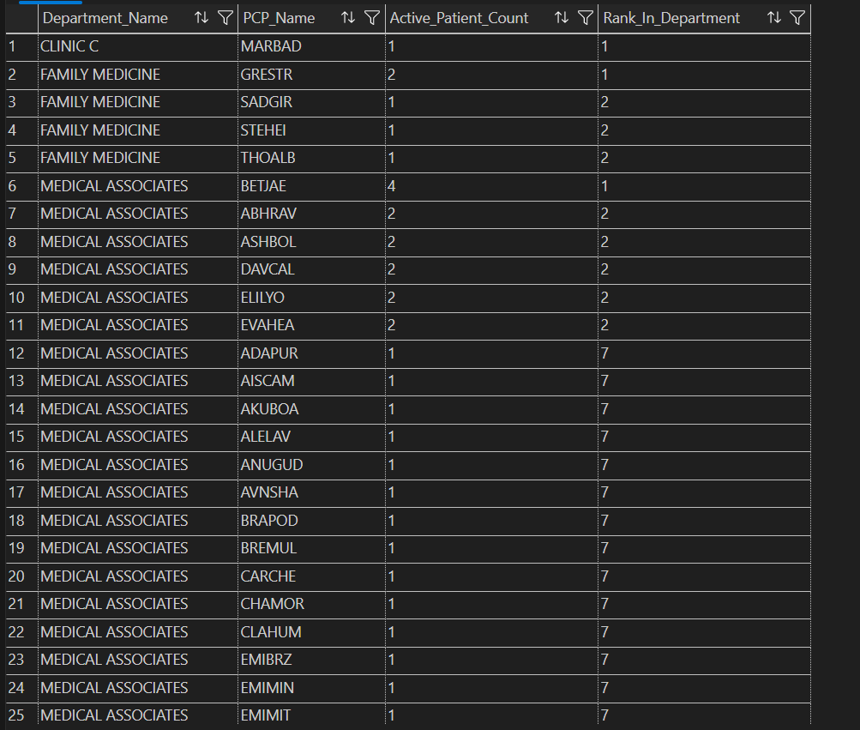

- Which PCPs have patients with the most ED encounters? Provide a rank ordered (descending) list.

SELECT
prov.Provider_Name AS PCP_Name,
COUNT(e.Encounter_Key) AS ED_Encounter_Count,
COUNT(DISTINCT e.Patient_Key) AS Unique_Patients_With_ED_Visits,
RANK() OVER (ORDER BY COUNT(e.Encounter_Key) DESC) AS Rank_Position
FROM dbo.encounters e
INNER JOIN dbo.patients p ON e.Patient_Key = p.Patient_Key
INNER JOIN dbo.providers prov ON p.PCP_Provider_Key = prov.Provider_Key
WHERE e.Encounter_Type = 'ED'
OR e.Encounter_Type_Description LIKE '%Emergency%'
OR e.Encounter_Type_Description LIKE '%ED%'
GROUP BY prov.Provider_Name, prov.Provider_Key
ORDER BY ED_Encounter_Count DESC;

